**RISK ASSESSMENT GUIDANCE**

1. **Scope**

The School name/Trust is fully committed to promoting the safety and welfare of all in our community so that effective education can take place.

This guidance is applicable to all those with responsibility for implementing risk management strategy and undertaking risk assessments for activities which are under their control, and should be read in conjunction with the School’s/Trust’s Health & Safety Policy and other relevant Trust or Academy/Nursery policies.

**2. Aims**

The School/Trust aims to ensure that:

• All risks that may cause injury or harm to staff, pupils and visitors are identified, and all control measures that are reasonably practicable are in place to avoid injury or harm

• Risk assessments are conducted and reviewed on a regular basis

**3. Legislation and statutory requirements**

Health and safety legislation requires every employer to adequately assess the risks to the health and safety of his/her employees to which they are exposed whilst they are at work. The risks to the health and safety of persons not in his/her employment arising out of or in connection with any work activity must also be assessed. These assessments should also identify and record any group of employees particularly at risk and be formally recorded.

Under the terms of The Health & Safety at Work etc. Act 1974 and Regulation 3 of the Management of Health & Safety at Work Regulations 1999, the employer has a duty to undertake:

“Suitable and sufficient assessments of the risks to the health & safety of employees and other persons, not directly employed, that could be affected by their undertaking”.

The requirement for risk assessments to be undertaken is not confined solely to these pieces of legislation.

Many other regulations require employers to risk assess specific areas of work, for example:-

* Control of Substances Hazardous to Health Regulations 2002
* Health & Safety (First Aid) Regulations 1981
* Personal Protective Equipment at Work Regulations 1992
* Health and Safety (Display Screen Equipment) Regulations 1992
* Manual Handling Operations Regulations 1992
* Lifting Operations and Lifting Equipment Regulations 1998
* Provision and Use of Work Equipment Regulations 1998
* Working at Height Regulations 2005

Model risk assessments, developed by professional bodies associated with schools (e.g. CLEAPSS; DATA; AfPE) are available on the internet. These must be adapted as required to the relevant setting.

### 4. DEFINITIONS

|  |  |
| --- | --- |
| **A risk assessment** | is a careful examination of how people may be harmed from a particular activity or situation. The assessment will help you to identify the likelihood of harm and whether you can reduce the risk to a reasonable level, through the introduction of control measures. |
| **Hazard** | A hazard is defined as something with the potential to cause harm, such as chemicals, electricity, working from ladders, an open drawer etc. |
| **Risk** | A risk is a likelihood of potential harm, high, medium, or low, that somebody could be harmed by these and other hazards being realised. This is usually evaluated by considering the likelihood of the harm occurring and the potential severity of the harm. |
| **Control measures** | Ways of preventing or minimising a person's exposure to a hazard. |

### 

**5. Roles and responsibilities**

**5.1 The Governing Body**

* Ensuring health and safety is being managed and risk assessments are being implemented
  1. **Headteacher/Principal**

### Ensuring that all risk assessments are completed and reviewed regularly

* Control measures identified in risk assessments are implemented

### Inform employees about risks and the measures in place to manage them.

**5.3 Staff and volunteers**

* Assisting with, and participating in, risk assessment processes, as required
* Familiarising themselves with risk assessments
* Implementing control measures identified in risk assessments
* Alerting the Headteacher/Principal to any risks they find which need assessing

Every employee is encouraged to develop a clear appreciation of the hazards pertaining to them in the workplace and what preventative/control measures exist. Own personal safety is an area in which every individual needs to be able to conduct their own risk assessment of their proposed activity to reach a decision about how to act. All staff attend a Health and Safety induction session which includes an introduction to risk assessment.

**5.4 Pupils and parents**

Pupils and parents are responsible for following the individual School advice in relation to risks, on-site and off-site, and for reporting any hazards to a member of staff.

**5.5 Contractors**

### Contractors are expected to provide evidence that they have adequately risk assessed all their planned work (see separate Managing Contractors Guidance).

### 5.6 VISITORS AND OTHERS

Visitors to the school and others for example people using the building as part of a letting, etc will be encouraged to report any risks, either observed by them or caused by them, to reception or a member of the site team. The receptionist or the site team member will inform the School Business Manager who will ensure the risk assessment is reviewed or carried out.

### 

### 6 HOW TO UNDERTAKE A RISK ASSESSMENT

There are five steps in undertaking a Risk Assessment.

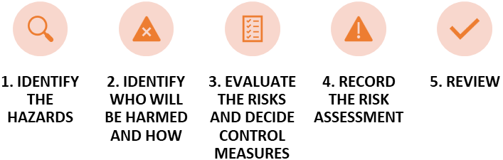

#### Step 1. Identify the hazard(s)

* First you need to work out how people could be harmed.
* Walk around your workplace and look at what could reasonably be expected to cause harm.
* Check manufacturers’ instructions or data sheets for chemicals and equipment as they can be very helpful in spelling out the hazards.
* Don’t forget to think about long-term health hazards.

#### Step 2. Decide who might be harmed and how

* For each hazard you need to be clear about who might be harmed (you don’t have to list everyone by name but rather by groups of people).
* In each case identify how they might be harmed, i.e. what type of injury or ill health might occur.
* Remember:
* some workers have particular needs, e.g. new and young workers or expectant mothers.
* people may not be in the workplace all the time, e.g. contractors, visitors; members of the public.
* if you share your workplace think about how your work affects others present;
* ask others if they can think of anyone you may have missed.
* Say how the hazard could cause harm.

#### Step 3. Evaluate the risk and decide on the precautions

* Having spotted the hazards, you have to decide what to do about them. You have to do everything ‘reasonably practicable’ to protect people from harm.
* List what is already in place and how the work is organised. You can compare this with good practice (HSE’s website [www.hse.gov.uk](http://www.hse.gov.uk)).
* Consider if you can get rid of the hazard altogether. If not, how can you control the risks so that harm is unlikely.
* When controlling risks, apply the Hierarchy of Control principles below:
* try a less risky option, e.g. switch to a less hazardous chemical;
* prevent access to the hazard, e.g. by guarding;
* organise work to reduce exposure to the hazard, e.g. barriers;
* issue personal protective equipment, e.g. goggles, footwear;
* provide welfare facilities, e.g. washing facilities, first aid.
* Involve staff so that you can be sure what you propose to do will work in practice and won’t introduce any new hazards.

Hierarchy of control:

Least effective

Most effective

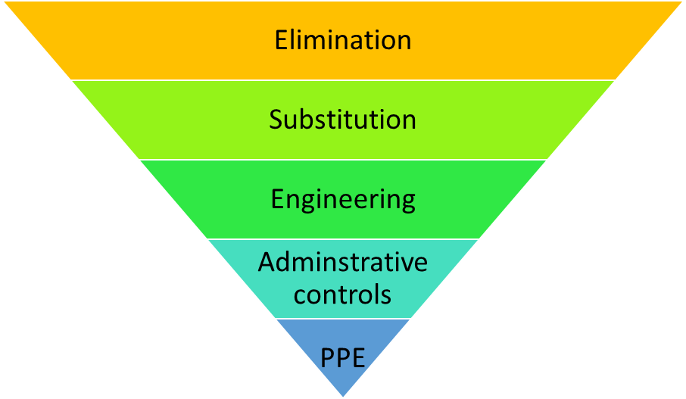

#### Step 4. Record your findings and implement them

* Write down the results of your risk assessment and share them with staff.
* You need to be able to show that:
* a proper check was made.
* you asked who might be affected.
* you dealt with all the significant hazards.
* the precautions are reasonable and the remaining risk is low.
* you involved your staff in the process.
* Make a plan of action to deal with the most important things first including:
* easy improvements that can be done quickly, perhaps as a temporary solution until more reliable controls are in place.
* long-term solutions to those risks most likely to cause accidents or ill health.
* long-term solutions to those risks with the worst potential consequences.
* arranging for training employees on the main risks that remain and how they are to be controlled.
* regular checks to make sure the measures stay in place.
* who will lead on what and by when.

### Step 5. Review your assessment and update if necessary

* You need to review what you are doing on an on-going basis.
* Have there been any changes?
* Are there any improvement you still need to make?
* Have you learnt anything from accidents or near misses?

The School/Trust will formally review their risk assessments every 2 years or if circumstances change before this date.

The School/Trust will have measures in place for monitoring the implementation of control measures.

Staff will have access to the risk assessments (insert location) and will be made aware of the key hazards in their area and measures in place to manage the risk.

Appendix A

|  |  |  |  |
| --- | --- | --- | --- |
| RISK ASSESSMENT | Activity/Area | | Insert school name |
| **Assessment completed by:** | **Date Completed:** |  |
| **PRINT NAME:** | **Next Review Date Due:** |  |

| **Hazard / Risk** | **Who is at Risk?** | **How can the hazards cause harm?** | **Normal Control Measures** | **Are Normal Control Measures** *Y/N/NA* | |
| --- | --- | --- | --- | --- | --- |
| **In Place** | **Adequate** |
|  |  |  |  |  |  |
|  |  |  |  |  |  |
|  |  |  |  |  |  |
|  |  |  |  |  |  |
|  |  |  |  |  |  |

|  |  |  |  |  |
| --- | --- | --- | --- | --- |
| **Additional Control Measures**  *(to take account of local/individual circumstances including changes such as working practices, equipment, staffing levels).* | **Action by Whom**  *(list the name of the person/people who have been designated to conduct actions)* | **Action by When**  *(set timescales for the completion of the actions – remember to prioritise them)* | **Action Completed**  *(record the actual date of completion for each action listed)* | **Residual Risk Rating** |
|  |  |  |  |  |
| **Reviewed by:**  **Signature:** | **COMMENTS:**  *Record any comments reviewer wishes to make. Including recommendations for future reviews.* | | | |
| **PRINT NAME:** |

|  |  |
| --- | --- |
| **RESIDUAL RISK RATING** | **ACTION REQUIRED** |
| **VERY HIGH (VH) Strong likelihood of fatality / serious injury occurring** | **The activity must not take place at all.**  You must identify further controls to reduce the risk rating. |
| **HIGH (H) Possibility of fatality/serious injury occurring** | You must identify further controls to reduce the risk rating.  Seek further advice, e.g. from your H&S Team, Consultant |
| **MEDIUM (M) Possibility of significant injury or over 7 day absence occurring** | If it is not possible to lower risk further, you will need to consider the risk against the benefit. Monitor risk assessments at this rating more regularly and closely. |
| **LOW (L) Possibility of minor injury only** | No further action required. |